***Casual Alchemy* July 20, 2019 *As Creative Aging***

***We are being lived by powers we pretend to understand.*  W. H. Auden**



***SYMPTOMS of Transition: There’s been a SHIFT.*** an Imbalance

***In Sleep, Friends, memory, hearing, seeing***

***Interests, Health, Strength, Responsibility, Centrality, Visibility, Standing.***

***You are Out of adjustment, There’s Unexpected Turbulence. Things May have Shifted during Flight***

***Listen Carefully as Menu has changed***

***Third Eye is blinking Top Chakra is opening***

*“Who am I when I am no longer doing, no longer productive, no longer indispensable to so many others? No longer wearing the masks?*

*Where does my attention go?*

*Am I shedding objects, clothes, books, body?*

*Am I grumpy, angry, annoyed, foggy, sad?”*

**WHY do this? *We Must.***

***“Search for the entwined and dramatic life of matter.”***

Mircea Eliade

***Casual Alchemy*** is about finding new ways to be with the Incessant Friction of Living;

increasing sensitivity to the connectedness of everything;

kindling access to the Creative Unconscious.

***WHAT TO DO?***There’s been a loss, yes, but what’s opened up, awakened?  There’s a Spiritual Hunger. It can be fed, adjusted. You Can Do It.

***SIMPLE Steps:  
Trust Curiosity.  Trust the Body. Be with Children.***

***Be with Nature.   Distrust Discourse Make Things***

***Take Small Risks  Make Order  Make Time for The Holy.***

***Creativity is not about “art” but about finding ways to keep making our lives meaningful.***

***In what ways can we become regenerative for ourselves, our families and  our community?***

***Practicing creativity eases  the difficulty of the many, tidal transitions of being human from birth***

***through growing up, aging and the bumps of jobs, war, physical and spiritual wounds***

***Try this Four-Fold Approach***                 *Start Anywhere!*

|  |  |
| --- | --- |
| ***Be Quiet: introspective, interior, patient. Remember dreams. This is private, meditative activity. It’s a form of Mindfulness.*** | ***Be Active:  intuitive, expressive. Find things to make, fix, build, care for. Learn a new skill. Use your Body*** |
| ***Be Public: engaging, explorative; Work and Play with others; Mentor, Volunteer. Share a skill you know.*** | ***Be Digestive: reflective, incorporative; Revisit these other activities. How did they work and feel? Keep a record. This is a “Grimoire”  Look it up.*** |

***Find Activities that feed you:*     *ASK,* if what you are doing or who you are with**:

* Stimulates ***Joy, Wonder, Awe?***
* Makes you feel ***Competent,  Playful***?
* Connects you  to ***Nature and Community?***

***1. Quiet Musings via curiosity, memory, imagination, patience, solitude, hunches, accidents…***

***Do a Profile of Yourself***: ***50 words or less***

***Be with Nature*** *Wander*Bare Feet?

***Stay casual***   This is an Exploration, not a debate or sales pitch.

***Recall Stories*** of your experiences in Nature: with animals, insects, weather…

***The gods are in the diseases* Your Symptoms?**What Spectrum are you on?

***Follow Present Threads:  What’s presenting?*** What lingers, vexes, haunts, peeves, annoys ?   ***Welcome Them*** as Directionals Clues, Puzzle Pieces to your Unconscious. They are not “Problems”. They are Your Familiars.

***Survey Needs:*** for ***Story, Awe, Feral, Making***,

***Consider New Ways, Models for Thinking: The Mosaic, The Kaleidoscope, The Loom, The Tapestry,***

***Organic Thinking,  Browsing, Cooking,******The Ellipse, Tides***

***Review your Lineages***: ***Who are your people?***

Ethnic, family, spiritual, karmic, archetypal, clan.

***What tasks were you born with?******What do you know about your Birth Experience?***

***2. Matterings:*** A wordless language of ***Material into Meaning*** via pattern and re-pattern

*to* access **Stories from The Unconsciou**s,

Allow for the power of the indistinct to emerge as tips, clues, hints.

    It’s cooperative participation, not control of the process. *This is MAGIC:*

     ways to access playful, provocative, hidden energy

***Make Marks***Use ***Pounded Pigment*** from stones, mud or flowers. Try ***Rubbing*** on various  textures;

     Try: mark-making with the smoke of a candle.  

***Make Tools*** (Wands/Talismans)  Find 2-3 Things: *feathers, shells, leaves, sticks*,

     Connect with yarn, dental floss, rubber bands; Add color,

***Make Things to Wear***    Particularly Hats, Masks, Jewelry

***Make******Gifts*** for friends, family, enemies***Just Leave Them Somewhere***

***Use Fragments and Empties:*** Blocks, Jars, Envelopes.  *What can you put in them?*

***Simple Activities*** :    Twist ties, Blocks, Rubbings, Balancing, Make Piles, Bundles

***3. Launchings****:* ***Public Ways to share discoveries, Make The Story Visible;***  

***Find Ways to Share Your Stories*** Vlog? Website? Pinterest?***Give*** ***Gifts to kindle*** ***Others.***

***Find others who share your sensibilities?***

***Find a Community Volunteer Project***a mural or a deck of cards that many people contribute to?

***Go Visit 3 Pines at the Community Center and see how you can engage***

***4. Review/Digest Often***

***What’s Repeating/Appearing?*** Are familiar themes appearing?  Do Family members/memories appear?

       Remember, it’s all about **MA**terial/**PA**ttern

***Light Touch!*** *not full arguments, but allurements.* ***Take Small Risks***

***Poetry often enters through the window of irrelevance.***M.C Richards

***Try Small Scale Objects:*** *How little of something is needed to make meaning?*

***Find Your Surreal name*** an anagram of the letters in your name.

***Start a Grimoire:****your record, journal of your Casual Making. Your discoveries*.

    In what Ways are you a ***Legacy Carrier?               What Talents Emerging!***

***Earth is Element of Old Age      from the North***

"the time to ***give yourself away***, to learn to d***well in timelessness*** and to ***tend the youth***." (Andy Fisher) .

The Time of Balance, Autumn/Winter, Body, Material Abundance, stability, health, hearth, home and Quietness.

**Earth Energy *is Cool, Dry, Feminine:*** Venus, Saturn, Earth, [onyx](http://www.witchipedia.com/mineral:onyx), [jade](http://www.witchipedia.com/mineral:jade),, [amethyst](http://www.witchipedia.com/mineral:amethyst), lead: Dull,  no sparkle, heavy   

**Evoked** *by any stone,* dish of soil, salt, *ochre, ivy.* brown-black-green*,* *darkness, thickness, bile, melancholy*

**Divinities**[***Demeter***](http://www.witchipedia.com/god:demeter)***,***[***Ceres***](http://www.witchipedia.com/god:ceres)***, the***[***Horae***](http://www.witchipedia.com/def:horae)***,***[***Persephone***](http://www.witchipedia.com/god:persephone)***,***[***Proserpina***](http://www.witchipedia.com/god:proserpina)***,***[***Hades***](http://www.witchipedia.com/god:hades)***,***[***Pluto***](http://www.witchipedia.com/god:pluto).

**Spirits**:  [*gnome*](http://www.witchipedia.com/beast:gnome)*s,*[*Faun*](http://www.witchipedia.com/beast:faun)*s,*[*Goblin*](http://www.witchipedia.com/beast:goblin)*s,*[*Satyr*](http://www.witchipedia.com/beast:satyr)*s,*[*Dryad*](http://www.witchipedia.com/beast:dryad)*s* [*Sylvestre*](http://www.witchipedia.com/beast:sylvestre)*s*

**Animals:**  Owl, Cat, [sphinx](http://www.witchipedia.com/beast:sphinx), [bull](http://www.witchipedia.com/beast:bull), [stag](http://www.witchipedia.com/beast:stag), [dragon](http://www.witchipedia.com/beast:dragon), [wolf](http://www.witchipedia.com/beast:wolf),

**Plants:**   ***earthy-smelling***, Grains grow near or in the soil: nourishing, hi-calorie, stored a long time

***GUIDES/PRACTICES  to the powers of the Creative Unconscious***

**to help “*give yourself away, learn to dwell in timelessness and tend the youth.”***   Andy Fisher

**1*. Keep Revisiting NEEDS (wonder/awe, nature/feral, skill/making, story)*                   *Use Ikigai***

***Ikigai***: *the source of value in one's life;  the things that make one's life worthwhile*          *see visual*

***Personal Inventory:*** *YOUR* earned history. Take responsibility. For better and worse

***What Stories are appearing?*** Eliz reading Ch Bks

**2*. ASK*  ”Do these People,  this Activity,”** *Stimulate Joy. Wonder, Awe?*

*Make you Feel Playful?  Competent?**Connected to Nature?  Community?,*

***Recognize/Welcome Emerging CLAN***Your Trickster, Greenman, Caretaker            ***Archetypes***

**3*.Be in Nature: “the enticing beauty and repellent brutality of nature”***  Francis Jammes

***Explore Organic language*** *(vs non-organic, heroic, egoic technical, binary)*

Where Mysteries, confusions, anomalies, ambiguities not ***Problems*** but normal growth:

     a *Fruiting. Ripening, decaying, a dormancy,* ***Welcoming Experience with****:*

***The******Chthonic*** of the Earth***,*** below, hidden, alive, decay/compost. Just outside Ego control

***The Feral*** = Illicit, marginal, outsider, animal, off-center, out of comfort zone

***CHAOS***: rising/falling action,  disorder, decay, through which the next form emerges.

***Transformative*** All are affected.  There are no sidelines 

**4*. Allow PLAY!*** *Seek Children as Guides* ***But Aging is not a return to being a child.***

***Loose parts***   Materials that can be moved, combined, taken apart, put back together in  multiple

      ways. No defined or directed use, Loose parts allow personal, idiosyncratic critical thinking.

***Take Small Risks/new competencies:*** the ***other*** way home  Coming to this group?

    ***Changing Pattern-Material-Meaning***                                                      ***Be Curious: “What If I…”***

***Let Go of Words*** try **Maps, Images**, What’s on your **cellphone?** Instagram,

***Explore new “skills”  or How To’s*** in Practical and Spiritual matters

    Try ***Haiku*** *Now-mood-contrast-* ***with Objects                                                                      Pinterest***

***MORE:***

**The Five Remembrances**

1. I am subject to aging. no way to avoid aging.

2. I am subject to ill health. no way to avoid illness.

3. I am going to die. no way to avoid death

4. Everyone/everything I love will change, and be separated from me.

5. Only true possessions are  my actions,  I cannot escape their consequences. not suppress knowledge of our frailty and impermanence. fears that lie in the depths of our consciousness, to be free of these fears invite the Remembrances into our consciousness and stop seeing them as enemies.       **Thich Nhat Hanh, Understanding Our Mind**

***The Three Occult Principles*:**

1. The universe is a single living substance.

2. The universe is comprised of interactive opposites. Mind and matter are a unified entity. Everything that exists corresponds in universal analogy –man/ woman is a microcosm of the universe.

3. Imagination is a real motivating force that can act upon matter in a subtle way

***Nepantla***

At some point, on our way to a new consciousness, we will have to leave the opposite bank, the split between

the two mortal combatants somehow healed so that we are on both shores at once and, at once, see through serpent and eagle

eyes. Or perhaps we will decide to disengage from the dominant culture, write it off all together as a lost cause, and cross the

border into a wholly new and separate territory. Or we might go another route. The possibilities are numerous once we decide

to act and not react.  La Conciencia de la Mestiza: Towards a New Consciousness   Bridges are thresholds to other realities,

archetypal, primal symbols of shifting consciousness. They  are passageways, conduits, connectors that connote transitioning,

crossing borders, and changing perspectives. Bridges span liminal(threshold) spaces between worlds, spaces I call **nepantla**,

a Nahuatl word meaning **tierra entre medio**. Transformations occur in this in-between space, an unstable, unpredictable,

precarious, always-in-transition space lacking clear boundaries. **Nepantla es tierra desconocida,** and living in this liminal

zone means being in a constant state of displacement--an uncomfortable, even alarming feeling. Most of us dwell in nepantla

so much of the time it’s become a sort of “home.” Though this state links us to other ideas, people, and worlds, we feel

threatened by these new connections and the change they engender

<https://thescene.com/watch/thenewyorker/leonard-cohen-the-last-interview>

[hikeintohistory](http://danielmack.com/hikeintohistory.html)[MakingMeditations.](http://danielmack.com/MakingMeditations.html)  [CreativeAging](http://danielmack.com/CreativeAgingApril2019.html)     ***Grimoire***   

David Brooks, The Second Mountain[aarp.org/health/dementia](http://www.aarp.org/health/dementia)

[***Suggestions for play/work at Home***](http://www.danielmack.com/HomePlay.htm)

[***www.thecasualalchemist.com***](http://www.thecasualalchemist.com)                  **James Hillman,** **The Force of Character**

**Donald Hall, The Third Thing                         Robert Frost, The Road not Taken**

**Robert Atchley, Everyday Mysticism            Andy Fisher,** <https://andyfisher.ca/>

***HOW to Begin? There are many ways.***

***Try this Four-Fold Approach:***

***Be Quiet, Be Active, Be Public, Be Digestive & Reflective***

***Be Quiet I only went out for a walk, and went in.*** John Muir

***Begin Within:*** OWN the Process, Dig deeper into biography. This is private, meditative activity. Be alone, introspective, interior. Remember dreams. Birth Experience. Consider your Ancestral Karma.This is the beginning of the ancient process of creating a **Grimoire**, a record book of the results of your encounters with the Creative Unconscious.

***Thumnail NOW:*** Concerns of the Day? What Cords Bind? Stuck song? Dreams? Face/Name from long ago

Consider your life with OBJECTS, Your cycles and Repeating Motifs? Your Totems?What natural objects or animal do you recognize and honor for spiritual significance?

***Your Signature Gifts*** *you now can share*?

***Your ways to enchant?*** *New Bottles for your Old Wine*

***Ikigai***: *the source of value in one's life; the things that make one's life worthwhile* *see visual*

***Legacy Carrier Are Other Talents Emerging!***

***What are your Stories*** languaged and not. What themes, characters seem to cycle through and repeat?***Oh, you again!”***

***Recognize/Welcome Emerging CLAN***

**Who are The Others** we carry with us?

***How are you*** Hestia, Hermes, Shapeshifter, Greenman, Caretaker, Shadow. Spellcaster, Trickster,

At Once: Puella, Femme Fatale/Witch, Crone, Sophia

***The Basic Archetypes***

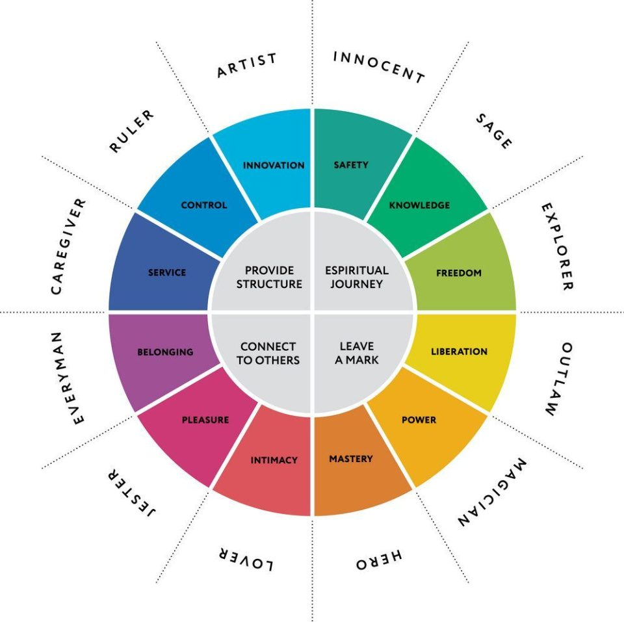

***MORE Pinterest***  
[conorneill.com/und=-12-jungian-archetypes/](https://conorneill.com/2018/04/21/understanding-personality-the-12-jungian-archetypes/) ***Bolen***

[Setting-Up-An-Ancestor-Altar](https://www.marlabrooks.com/single-post/2016/10/11/Setting-Up-An-Ancestor-Altar)Leonardo’s 7 Virtues 7 Souls Egyptian

***Allow/Explore/Consider Earlier Ways,***

***Other ways, Lenses, Pathways***

[***http://www.danielmack.com/wayward/waystoseeanew.html***](http://www.danielmack.com/wayward/waystoseeanew.html)

***Organic/Vegetable thinking*** (vs non-organic, heroic, egoic, technical, binary, )Where Mysteries, confusions, anomalies, ambiguities are not Problems but normal growth: Organic Language includes *Fruiting. Ripening, decaying, dormancy, rust, ferment, cook, stew. Changing weather fronts* *There are seasons, cycles, territories, ranges. It includes Lyme Disease and the BioBloom!* It is so unlike the Technical Language we are used to.

***Kaliedoscopic Thinking*** Not a Logic, a program, but ***Tidal.*** Same stuff, jumbled up in new relations bringing in different meaning. Ongoing Alt Organization of Same Materials

***Celtic Geometries:*** Things changing SHAPE, but not ending.

***Spiral*** Helical ***Thinking*** always re-forming; gaseous, not solid ; Always in transition/more or less visible, palpable. ***described by Surrealist Kurt Seligmann: as a helical changing spin of the perceived (present), the remembered(past) and the imagined (future)***

***The Iceberg***  *So Much Submerged!*

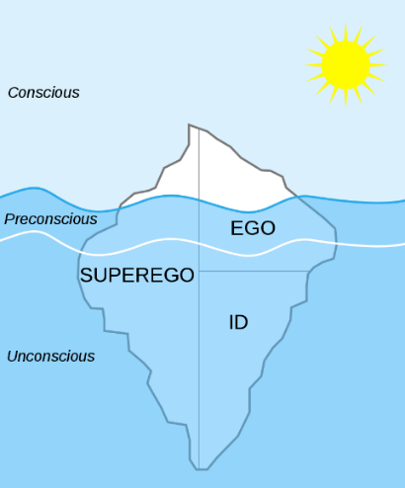

***Life as a Bulls Eye***

There was once a general of war who had spent his entire perfecting his skill in all the arts of war, but he was weary and had but one wish: to spend the rest of his days studying archery, the one art of war he had not mastered. He had heard of Master archers, living in distant monasteries, who spend a lifetime doing nothing else but perfecting their skill. He entered the monastery and begged to join them and pass the remainder of his days on this earth studying archery. For 10 years that is what he did. Then, when he had perfected his skill as an archer, the abbot of the monastery came to the general and said, "It is time to leave." The general was shocked and protested, saying that his life in the world outside the monastery was over. The abbot  
insisted that the general must leave. To advance his skill, it was necessary for the general to go out into the world and teach what he had learned.

And so he left the monastery and returned to the village of his birth.   
As he neared his old village, he noticed a bull's-eye on a tree, with an arrow in the exact center. The general was surprised by this and even more so when he noticed more trees with bull's-eyes and arrows in the center. Soon he saw many barns and homes with bull's-eyes and arrows dead center. And even in the village center, on every wall of every building was a bull's-eye with an arrow right in the center.   
  
The peace he had gained from his years of monastic life was gone. He was indignant to find that after 10 years of study and reflection there lived an archer more skilled that he. He went to the town elders and demanded that the archer responsible for this perfection meet him at the edge of town by the mill, in one hour.   
 He waited but as the hour approached no one came. There was, however, a young girl playing by the river. The girl noticed him and came over. "Are you waiting for someone?" she asked, looking up at the general. "Go away," he said, irritated.   
"No, no," said the girl, " I was told to come and meet someone here."   
The general looked unbelievingly at the little girl and said, "I'm waiting for the Master archer responsible for the hundreds of perfect shots I have seen." "Well, that's me then," said the girl.   
The general, still indignant looked skeptically at the girl, "If you are telling the truth, then explain to me how you can get a perfect shot every single time you shoot your arrow."   
"That's easy," said the girl, brightening. "I take my arrow and I draw it back very tight in the bow. Then I point it very, very straight and let it go. Wherever it lands I draw a bull's-eye.

***Be Active***

***Develop* multiple entry points** to your Creative Unconscious**, *We are using the familiar to encounter the sacred***

PAUSE OFTEN See What Emerges! Allow for messaging, Be With The Shift, Hunger, Loss, Interest, Symptoms, Clues as ways to depth, not just growth

Find a Surreal name… It’s an anagram of the letters in your regular name

Find things to make, fix, build, care for. Learn a new skill. Use your Body. Take Small Risks Learn Something New; Play, not work new competencies

***Assume competency:*** that you are capable of appropriate self-care. Be Positive Resist self-demeaning

Celebrate Your Half-Full Glass!

***Trust Patience***, waiting; Resist control, Wander,

***Trust the Indirect,*** The chthonic, the hidden, the unseen.

It’s Happening, whether you can see it or not.

Pay attention to Glimpses, Coincidences, Accidents, Spills, *See what emerges, not how well planned thins are.*

***Rebalance Your Magic/Logic*** Trust Intuition, The Casual, The Unplanned

***Find/Share Thin Places*** **All**  places and locations have their own power and potency. We respond to this. It includes history, mystery and the geo-cosmic forces of gravity, light, magnetism, solstices, equinoxes, lunar cycles, the plants, animals, climate.. I’ve been writing and sharing about this for several years.

***Allow PLAY! Seek Children as Guides*** ***Be Curious Loose parts*** Materials that can be moved, combined, taken apart, put back together in multiple ways. They have no inherent defined or directed use,. Loose parts allow personal, idiosyncratic critical thinking. Simon Nicholson 1971

***Violate*** Change Pattern-Material-Meaning and Explore Disorder

***Be with Matter***

***Matter is spirit moving slowly enough to be seen****.*

*Teilhard de Chardin*

**See, Find, Collect Add, Subtract Violate, Restore** Experiments in how meaning happens from simple common objects, tools and activities:

**Making is all about Family:** ***MATER and PATER!***

It’s being drawn to certain MAterials and discovering ways to work with them that have meaning for you. Finding your PAtterns of Meaning. Both are needed: MAterial and PAttern

**COMMON OBJECTS/TOOLS**

***Everyday mysticism:Using the familiar to highlight the sacred:***

Karl Rahner

penknife sandpaper paper cutter needle clippers string-yarn drill glue(s) band aids dental floss markers saw

hammer wire camera paper sticks rasp tape penci

stapler pins stirrers clamps

flower frogs paper clips feathers cards

driftwood butcher paper buttons bones

thumbprint bark charcoal wax

ash rusted objects Black dirt stones

envelope corners black sand old stamps lint

road kill spills/stains skeletal leaves shells fingernails leaves mesh bags dust flowers egg cartons rubber bands sticks

[**window sill bugs**](http://thechive.com/2009/10/07/dead-fly-art-surprisingly-hilarious-15-photos/) small containersbits of mirror stickers

fruit ***more?***

**ACTIONS of MATTERING**

Wandering Noticing Playing Finding

Gleaning Collecting Arranging Stacking

Storing Sharing Altering Editing

Violating Cutting Heating Coloring

Shedding Marking Boiling Dyeing

Scratching Piercing Carving Charring Pounding Shaping Breaking Sewing

Knitting Defacing Joining Hiding

Binding Bundling Weaving Drilling

Repairing Fixing Recycling Gifting

Collage Assemblage Re-Purposing Tearing

Emptying Remembering Filling ***more??***

**A Few Specific Prompts:**

***Try Marking*** on 2’x 3” cards: with dirt, ink, the Smoke of a Candle, spilled coffee, fingerprint or bandaid Try a Rubbing

***Carry a 2 x 3 Card*** and see what you put on it

***Try Making*:** Put something in empty jar/cup, box, tin Just

***Bundle*** a few objects with a twist tie orstring,

**How little of Matter** do you need to Make Meaning?

*I often painted fragments of things because it seemed to make my statement as well as or better than the whole could.” Georgia O'Keeffe*

***Try Haiku with Objects*** Choose something of the moment, something of nature, something of personal importance and combine in a way that reveals a contrast**.**

***Fix Things*** Accentuate the repair; The fix more precious

***Make GIFTS for friends***

***Unmake and Destroy***

***Be Public***

***engaging, explorative; Work and Play with others;***

***Mentor, Volunteer. Share a skill you know.***

***experiments in Magic, Not Logic***

Do not be daunted by the enormity of the world's grief.

Do justly now, love mercy now, walk humbly now.

You are not obligated to complete the work, but neither

are you free to abandon it. Talmud

***Find/Gather/Share* Leave Something for next visitor**

***Share/Volunteer*** Find/Work/Play/Kindle Others

***Find a Collective Community Project***

***Be with Children*** Why? Elders share with them The ELLIPSE of Life: ***Pre/Post Institutional Life***

***Where Does Your New CLAN gather?: PINTEREST/***

***Meet-Ups:*** Theme, Food, Share Obj,

***BUT ALWAYS ASK*  ”Do these People, this Activity,”** *Stimulate Joy. Wonder, Awe? Make you Feel Playful? Competent?**Connected to Nature? Community?*

***Serving requires us to know that our humanity is more powerful than our expertise. Only service heals. Service is not an experience of strength or expertise; service is an experience of mystery, surrender and awe. Helpers and fixers feel causal. Servers may experience from time to time a sense of being used by larger unknown forces. Those who serve have traded a sense of mastery for an experience of mystery, and in doing so have transformed their work and their lives into practice***  [/HelpingFixingServing.pdf](http://www.uc.edu/content/dam/uc/honors/docs/communityengagement/HelpingFixingServing.pdf)

***Be Digestive*** reflective, curious, incorporative; Revisit these other activities. How did they feel?

***Read Poets Rumi Mary Oliver Robert Bly Mason Williams Lucille Clifton***

***Gather/Share* terms of interest, like these:**

***Spiritual Hunger Loss of Soul punctum***

***Hungry Ghost suisecki Biobloom***

***The Numinous Surrealism Ordinary magic***

***Negative Capability Archetypes Ikigai***

[***mother-wound***](https://womboflight.com/why-its-crucial-for-women-to-heal-the-mother-wound) ***Nepantla Chthonic***

***Archetypal Time hypnopomp Ancestral Karma***

***Active Imagination psychosphere Ceremonial Time***

***Helical Thinking Limerance bibliomancy***

***Fluid/Crystalline Intelligence Golden Shadow***

Kintsugi: *golden repair* *“winter fires”* ***Black Dog Days*** Richard Louv’s “nature deficit disorder.” [**Affinities**](http://www.danielmack.com/wayward/affinities.htm)

**Alchemy**: practiced ability to transform [**Archetypes**](http://aras.org/whatarearchetypes.aspx)

[**Bricoleur**](http://www.danielmack.com/wayward/colors.htm)     [***more***](http://web.utk.edu/~unistudy/ethics96/dlm1.html) [**Creative Fitness**](http://www.danielmack.com/creativefitness5.09.html)

**Foraging Economy:**  interdependent relationship, not too hierarchial; heterarchial; ebbing groups, gleaning

**Holswege**: a path through Forest that leads nowhere.  [***more***](http://www.danielmack.com/wayward/behere.htm)

**Inherent Vice***. ~*The tendency of material to deteriorate due to the essential instability of the components or interaction among components.

**Magical Thinking Melancholy Wabi** **Sabi**

**Protective Custodies:** conscious and unconscious ways we behave to keep us out of harms way while transformations are happening.

***Work on that GRIMOIRE***

Your private record of encounters, inspirations, alterations, explorations, violations, exfoliation, sheddings, regrets, successes… There are Active/Passive, Conscious/Unconscious forces at play. They appear in random images, scraps of paper.

Just Recognize, Note, List, Map these Clues to What Happening/Gathering Around You right now.

***Your Body-Now?*** *DREAMS SYMPTOMS MEMORY your Foods/Drinks Sleep Rhythms*

***What Objects Collect around you-now?*** Your Dresser Drawers?*What are you Saving*

***Tasks on your To Do List?***

***Chance Encounters?*** Animals, Insects, Machines, People? *From Memory, from here/Now*

***Encounters with the Unseen?*** emotions, memory?

***Recent ahas?*** (quotes, books, insights, comforts, exchanges)

***How do you OUTER/share?***

***What Places Do You Regularly Go?***

***Recent Successes, Experiences, Engagements?***

***How are you visible, celebrated?***

***What are you Shedding: Moving, Giving, Selling***

***Recent mistakes, regrets, accidents, losses?***

***What do you Make?***

***How/When/Why do you Exit, Check-Out***

transform fear of death into blending w reminders of ancestry Aging is not a return to being a child,

Atlantic [work-peak-decline/0/](https://www.theatlantic.com/magazine/archive/2019/07/work-peak-professional-decline/590650/) Examine or nots STEAM MSM Roe Exp w Old People? Still Saving?

Elders: to help “give yourself away, learn to dwell in timelessness and tend the youth.” Andy Fisher