***The Casual Alchemist* 8.28.19**

***Fast Start Playbook***

***for Spiritual Explorers: seekers, elders, outliers,***

***caretakers, the wounded and the healing.***



***Exploring Self, Community, Nature and Unconscious Intelligence with chance, coincidence, accident by making objects as compasses, tools of personal exploration.***

***These are not tasks, but invitations, idyls to “kindle magic in an unmysterious world*** .” Joseph Stella

***This is the start of our personal Book of Shadows and our shared Grimoire***

***We are being lived by powers we pretend to understand*** W. H. Auden

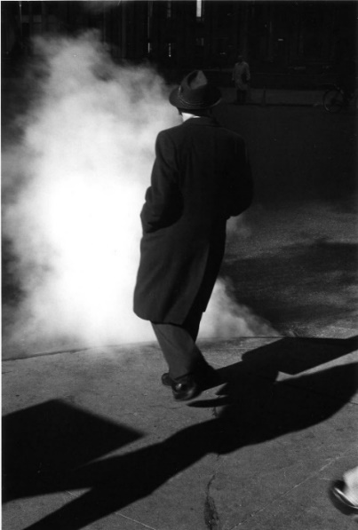***“The soul’s duty is to listen to its own desires and abandon itself to its master passion”*** Rebecca West

***We ALL have a Spark of the Divine; the Joy*** Kabbalah

**‘*La ruta nos aportó otro paso natural’***

***“The path provides the natural next step”***

***FAST START!***

***You choose where to Start***

***Be Alone/Quiet Trust Curiosity***

***Consult current symptoms Seek Awe/Wonder***

***Take Small Risks Play***

***Pause/Wait Make Things***

***Make Time for The Holy Trust the Body Distrust Talk/Words Be with Children***

***Give Things to Others Repair Something***

***Recall a Dream/A Memory Revisit/Repeat***

***Find/Share Thin Places Make a Presence***

***Be with others ; Find Clan Be with Nature***

***Put Something in an Empty Container***

***Allow for The Unresolved/The Unseen/Ambiguous***

***Read:*** *Kandinsky’s The Spiritual in Art, Rumi*

***Keep Notes on your experiences.***

***Honor the casual. This is not a Project, nor Art, nor a Test, nor a Challenge.***

***Approach all this sideways: alert to coincidence, hunch, accident, mood,***

***Move on if nothing seems to be arising. It has its own ways and means.***

***Three Moods to start from: Quiet, Active or Public Where are you right now?***

***QUIET  
  
Be Alone/Quiet***

***Just pause, wait for something to arrive.***

***You are the spider who has just woven***

***this beautiful web***

***Trust Curiosity.***

***It’s a shy, indistinct flicker or***

***shadow of interest***

***Seek Awe/Wonder.***

***Who, What, Where brings on***

***moments of brightness?***

***Consult the Body***

***and your current symptoms. What and where are the aches, or the feelings of well-being?***

***Make Time for The Holy***

***Be with Nature***

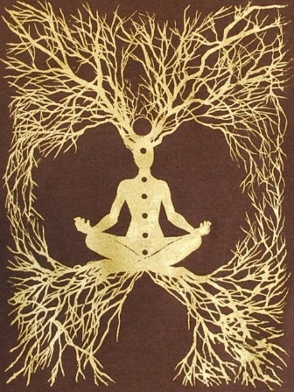

***Distrust Talk/Words***

***Allow for The Unresolved, The Unseen, The Ambiguous***

***Recall a Dream/A Memory***

***ACTIVE***

***This is engaging your Body, The Material World and Your Heart***

***Play.***

***The opposite of play is not work.***

***It is depression.***

***Take Small Risks.***

***Just a stretch beyond the usual,***

***the comfort zone***

***Attach 3 things together***

***with wire, string or dental floss***

***Empty Container.***

***Get a jar, a box, a tin, a cut of wood.***

***Put something in it or on it.***

***Make Marks on a piece of paper***

***With ashes, flower petals, coffee stains; Draw some shapes around them to reveal clues to the Message, the Map.***

***Repair Something***

***This is practicing caretaking and creativity***

***PUBLIC***

***Find Ways to be in Community***

***Be with Children***

***Find Clan***

***Make a Presence***

***Create something for others to discover***

***in a park, a field, a corner.***

***Learn about Wonder Rooms***

***Give Things to Others***

***Revisit/Repeat All This.***

***Like the tides, they come in and go out all the time. Similar, and New.***

***Make some notes on what worked, what surprised you…***

***This is the Stuff of the Book of Shadows, that Grimoire: records of your experiences with the powers of enchantment, encounters with the Holy***